The Leiston Surgery
Main St, Leiston, Suffolk, IP16 4ES
Tel 01728 830 526
www.leistonsurgery.com
sec.leistonsurgery@nhs.net
Dr Karen Blades
Dr Nicola Maggs
Dr Imran Qureshi
Dr Michael Barstow
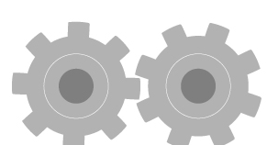
The Leiston Surgery Patient Text Communication Preferences

Title |  | First Name
Surname |  | Date of Birth
Address
Address |  | Postcode
Email Address |  | Mobile Number

If you give consent for communication by SMS text messaging and have a mobile number attached to your records, we may contact you in regards to the following things-

- You will get an automatic SMS to confirm any appointment you book with us
- To inform you of any test results (subject to your preferences below)
- To offer you a vaccination
- To ask you to book an annual health check if you have any long term medical conditions
- To request that you contact reception/book an appointment

Please not that if another person’s mobile number is attached to your records they will also receive the same message.

My text communication preferences are: (please tick all that apply):

Give consent for communication by SMS text messaging
Declined consent for communication by SMS text messaging
Give consent to receive test results by SMS text messaging
Declined consent to receive test results by SMS text messaging

I understand and agree with each statement (please tick):

I will be responsible for the security of the information that I receive
If I choose to share my information with anyone else, this is at my own risk
I will contact the practice as soon as possible if I suspect that my information has been accessed by someone without my agreement
If I think that I may come under pressure to give access to someone else unwillingly I will contact the practice as soon as possible

Signed: ___________________________________ Date: ___________________

